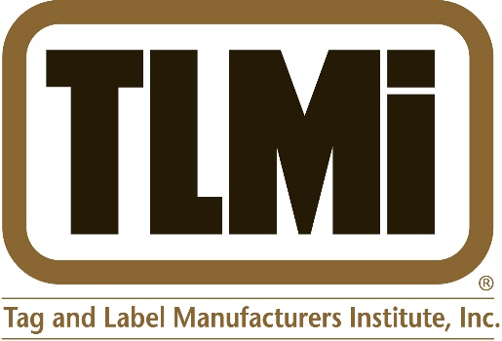
FOR IMMEDIATE RELEASE

October 10, 2015

PRINTING EXCELLENCE IN NORTH AMERICAN COMPETITION RECOGNIZED
Second Place Award for International Label & Printing Co.
Announced at the 2015 Tag and Label Manufacturers Institute (TLMI) 38th Annual Awards Competition Dinner

Colorado Springs, CO— The Tag and Label Manufacturers Institute (TLMI) has announced that International Label & Printing Co., Inc. of Elk Grove Village, Illinois is an award winner in the 2015 Annual Awards Competition. The judging was concluded on July 15, 2015 and the winners were announced at the recent TLMI Annual Meeting Awards Dinner at the Broadmoor Hotel & Resort in Colorado Springs, Colorado.

International Label & Printing won a second-place award in the Wine & Spirits – Digital Printing/Ink Jet category for its Village Vintner Winery Zinfandel label entry.

A panel of twelve distinguished industry judges with extensive experience in printing and print production were commissioned to evaluate the work. Each entry was judged on its own merit in a category with similar printed pieces. The judges commented: "The Village Vintner Zinfandel label was presented a second place award in one of the most competitive classes, Digital Ink Jet Wine and Spirits. The design and purpose of the label was well thought out and provides for an elegant shelf appeal. The judges were particularly impressed with the level of difficulty in the die shape and overall execution of the label production. This was a well-deserved honor for a label that sets the bar for the wine and spirits market segment."
“It is an honor for us to have been chosen for this award by the TLMI,” said Mark Turk, President/CEO of International Label. “It is a direct reflection of our tremendous staff, suppliers such as Spinnaker Coating, RotoMetrics, QSPAC and Domino, along with the designers and fine folks at the Village Vintner Winery & Brewery.”

For more information, call Tony Dardano of International Label & Printing at:
(800) 244-1442, or visit the website at www.internationallabel.com.

For more information about the TLMI Awards, call Susan Bachman at:
(800) 533-8564, or visit the website at www.tlmi.com.

Founded in 1933, TLMI is the premier association for the label and package printing industry, and is a member-driven association strongly committed to providing business solutions that enhance the prosperity of its members and the narrow web tag, label, and packaging industries.

